|  |  |  |  |
| --- | --- | --- | --- |
| **Class: FYMCA Div: A Semester: II** | **Course Code: MCA01554**  **Course Name: Java Programming Laboratory** | | **Batch: F1** |
| **Name: Abhijeet Joshi** | | **Roll No: 51023** | |
| **CO No: CO515.3** | | **Assignment No:** 9 | |

**PRACTICAL SUBMISSION RECORD- A.Y. 2024-25**



Progressive Education Society’s

**MODERN COLLEGE OF ENGINEERING, Pune -05.**

(An Autonomous Institute Affiliated to Savitribai Phule Pune University)

**MCA Department**

**Title**: Write a Java program to concatenate multiple text files sequentially into single file. Accept file names from command line arguments.

# Code:

package Filehandling; import java.io.*;

public class AcceptFileName {

public static void main(String args[]) { if (args.length < 2) {

System.out.println("provide two file name through command line"); return;

}

String name = args[0]; String file2 = args[1];

System.out.println("The first file name is: " + name); System.out.println("The second file name is: " + file2); String output = "outputfile.txt";

File file = new File(output); try {

if (file.createNewFile()) {

System.out.println("Output file is created: " + file.getName());

} else {

System.out.println("File already exists.");

}

} catch (IOException e) {

System.out.println("An error occurred while creating the output file: " + e.getMessage()); e.printStackTrace();

return;

}

try (BufferedReader br = new BufferedReader(new FileReader(name)); BufferedReader br2 = new BufferedReader(new FileReader(file2)); FileWriter writer = new FileWriter(file, true)) {

String content;

while ((content = br.readLine()) != null) { writer.write(content + "\n");

}

String content2;

while ((content2 = br2.readLine()) != null) { writer.write(content2 + "\n");

}

System.out.println("content of the two file is written in output file");

} catch (IOException e) {

System.out.println("An error files: " + e.getMessage()); e.printStackTrace();

}

}

}

# file.txt content

File Handling is an integral part of any programming language as file handling enables us to store the output of any particular program in a file and allows us to perform certain operations on it.

# File2.txt content

In simple words, file handling means reading and writing data to a file.

# Output:

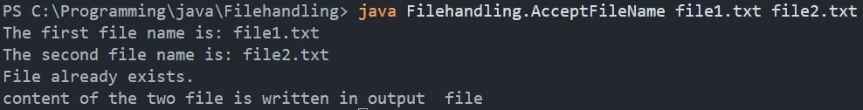

1. **Outputfile.txt content after concatenating the content of file and file2**

File Handling is an integral part of any programming language as file handling enables us to store the output of any particular program in a file and allows us to perform certain operations on it.

In simple words, file handling means reading and writing data to a file.